Boston Food Establishment Inspections

The table contains records of business licenses and inspections, specifically health-related licenses. Each record represents a single inspection and includes details about the business, license status, and inspection results.

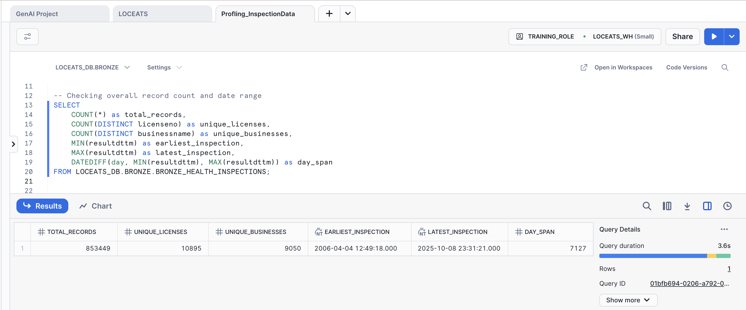
Dataset Volume:
- Total Records: 853,449
- Unique Licenses: 10,895
- Unique Business Names: 9,050
- Earliest Inspection: April 4, 2006 (12:49:18.000)
- Latest Inspection: October 8, 2025 (23:31:21.000)
We have 853,449 inspection records in total, covering 10,895 unique licenses and 9,050 unique businesses. The inspection dates range from April 4, 2006, to October 8, 2025, spanning a period of 7,127 days. This indicates that the dataset captures a long history of health inspections conducted over nearly two decades, providing extensive temporal coverage for analysis.

Null Value Analysis Across Key Columns:
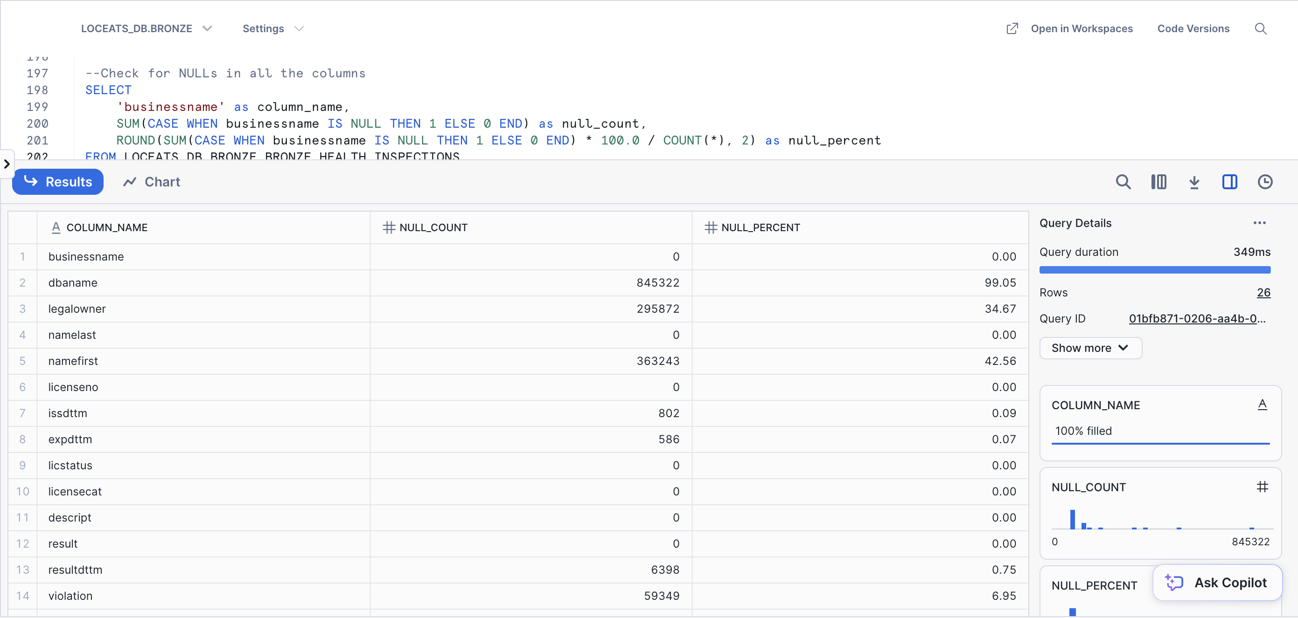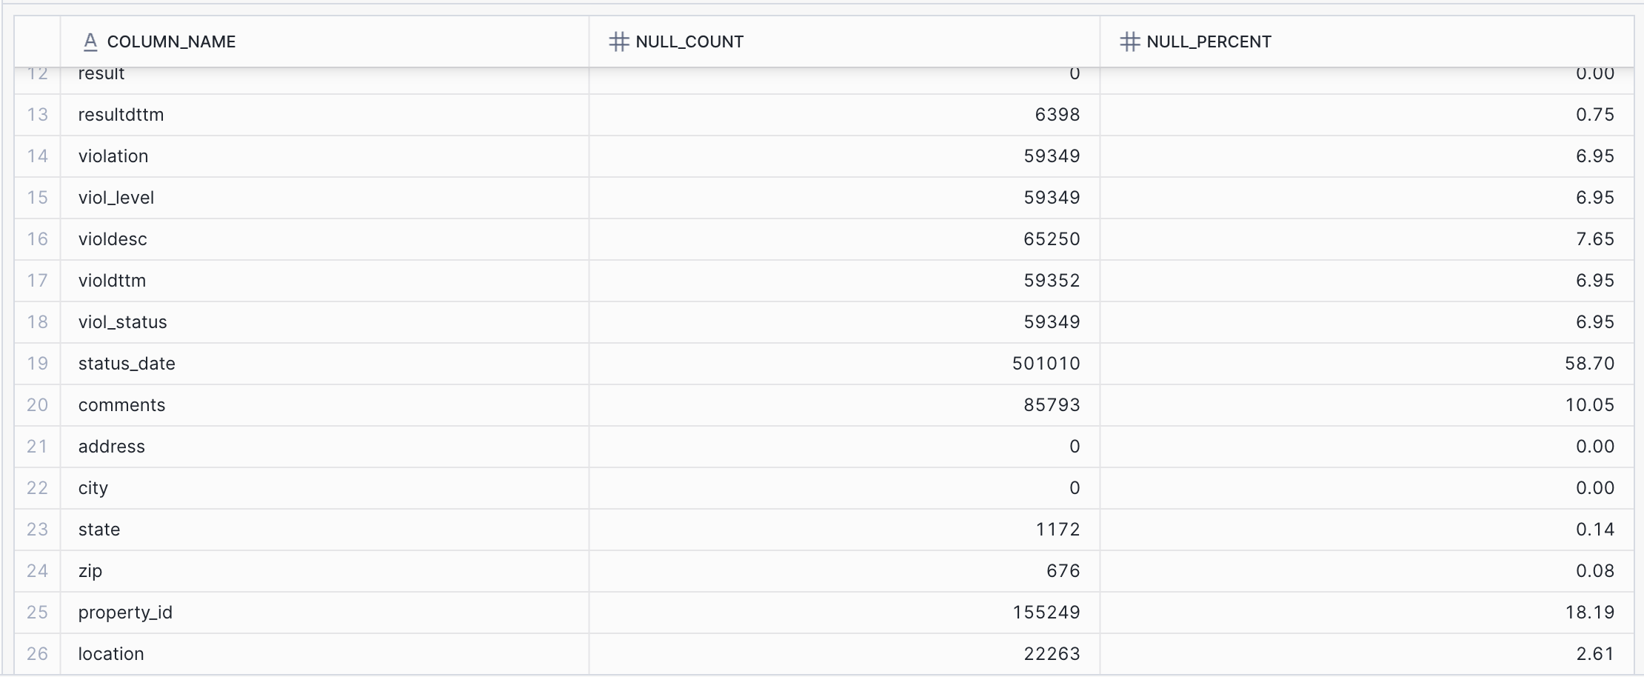

Observations:
- 10 columns with perfect completeness (0% NULL)
- 1 nearly unused field: dbaname (99% NULL)
- 2 fields with major gaps: status_date (59%), namefirst (43%)
- Violation fields: Consistently ~7% NULL (likely records without violations)
- Critical fields complete: businessname, licenseno, address, result

Column | NULL Count | NULL %
businessname | 0 | 0.00%
dbaname | 845,322 | 99.05%
legalowner | 295,872 | 34.67%
namelast | 0 | 0.00%
namefirst | 363,243 | 42.56%
licenseno | 0 | 0.00%
issdttm | 802 | 0.09%
expdttm | 596 | 0.07%
licstatus | 0 | 0.00%
licensecat | 0 | 0.00%
descript | 0 | 0.00%
result | 0 | 0.00%
resultdttm | 6,398 | 0.75%
violation | 59,349 | 6.95%
viol_level | 59,349 | 6.95%
violdesc | 65,250 | 7.65%
violdttm | 59,352 | 6.95%
viol_status | 59,349 | 6.95%
status_date | 501,010 | 58.70%
comments | 85,793 | 10.05%
address | 0 | 0.00%
city | 0 | 0.00%
state | 1,172 | 0.14%
zip | 676 | 0.08%
property_id | 155,249 | 18.19%
location | 22,263 | 2.61%
License category distribution:
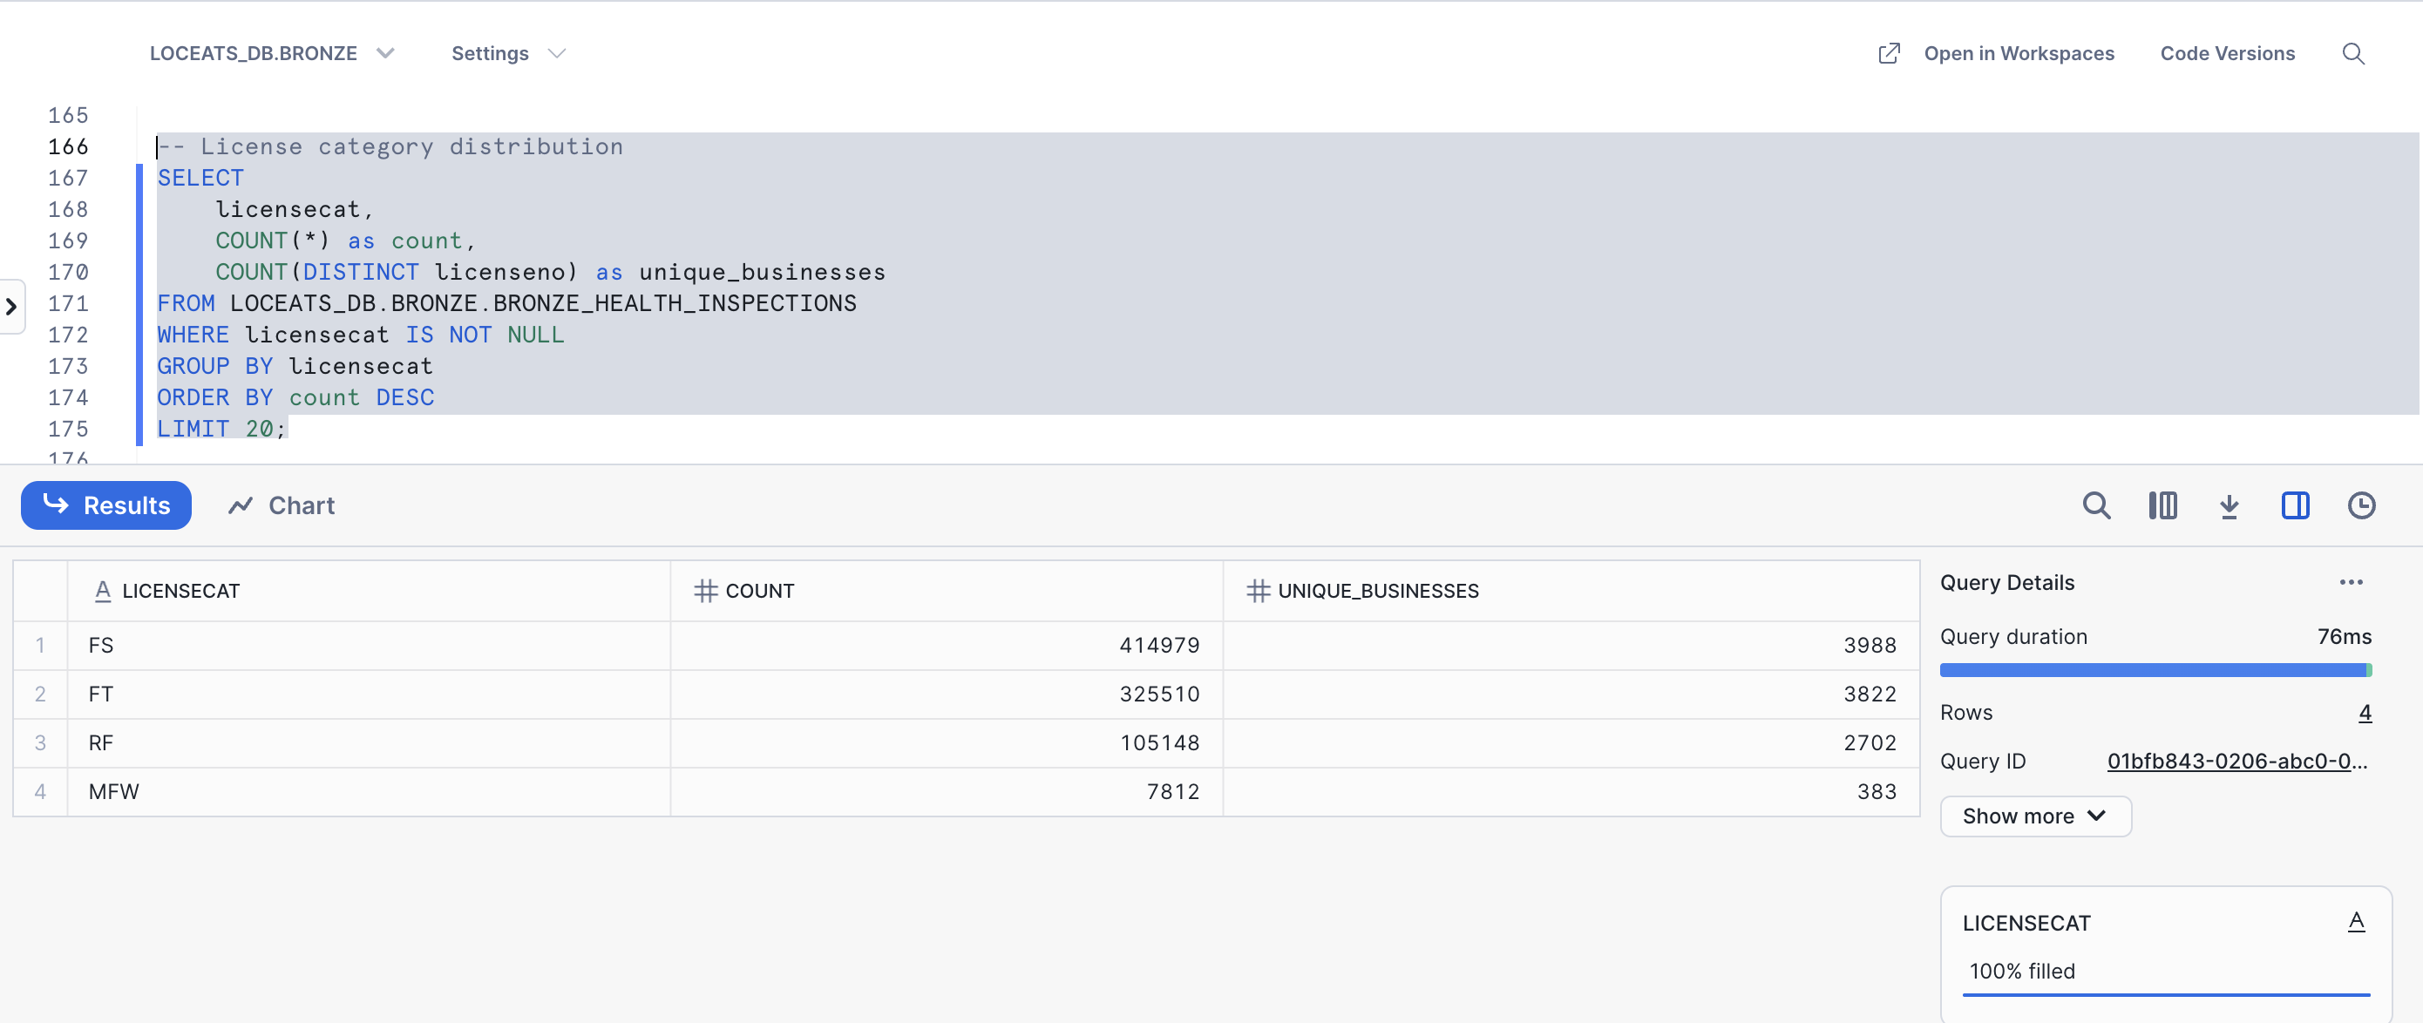
The dataset contains four main license categories — FS, FT, RF, and MFW. The FS category has the highest number of inspections (414,979 records), followed by FT (325,510), RF (105,148), and MFW (7,812). Most inspection records belong to the FS and FT license types.

Geographic Distribution of Inspections:
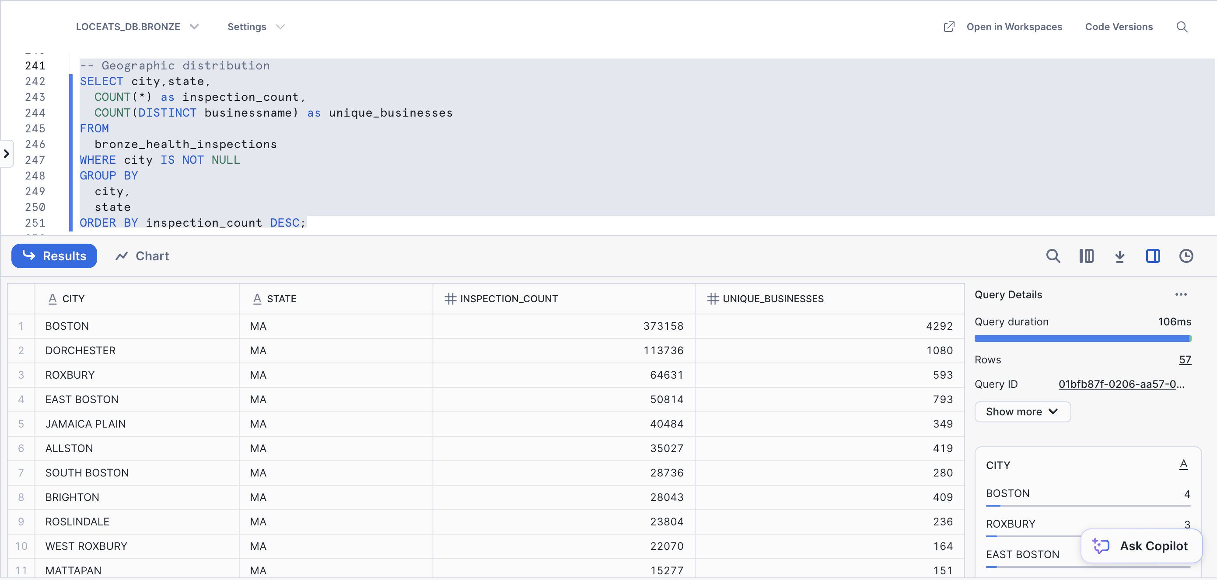
Most of the inspections occur in Boston, with 373,158 inspection records across 4,292 unique businesses. Other areas with high inspection activity include Dorchester (113,736 inspections), Roxbury (64,631), and East Boston (50,814).

Most Common Violations:
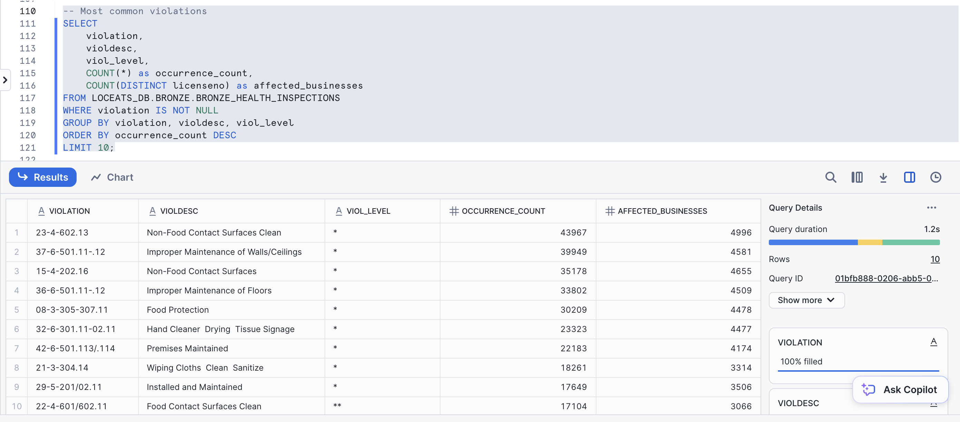
The most frequently occurring violations in the dataset are related to cleanliness and maintenance. The top violation is “Non-Food Contact Surfaces Clean” (violation code 23-4-602.13) with 43,967 occurrences, affecting 4,996 unique businesses. Other common issues include “Improper Maintenance of Walls/Ceilings”, “Improper Maintenance of Floors”, and “Food Protection”. Most violations are categorized under minor or standard levels (*), indicating recurring operational hygiene issues across establishments.
Check for inconsistent:
Business Name Format Inconsistencies
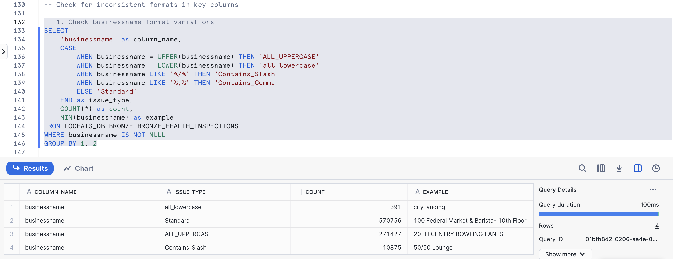
The business name field contains multiple format variations that require standardization. Most records (570,756) are in mixed case format, while 271,427 records are in ALL_UPPERCASE, 10,875 records contain slashes within the name, and 391 records are entirely lowercase.
Transformations: All business names should be converted to uppercase format for consistency. The mixed-case and lowercase entries will be transformed to match the uppercase standard (e.g., "city landing" becomes "CITY LANDING"). Special characters including slashes, ampersands, and hyphens should be preserved as they are legitimate business identifiers (e.g., "50/50 Lounge" becomes "50/50 LOUNGE"). Multiple consecutive spaces will be reduced to single spaces, and leading/trailing whitespace will be trimmed. This standardization will ensure consistent matching operations when joining with external restaurant datasets.

License Number Format Inconsistencies:
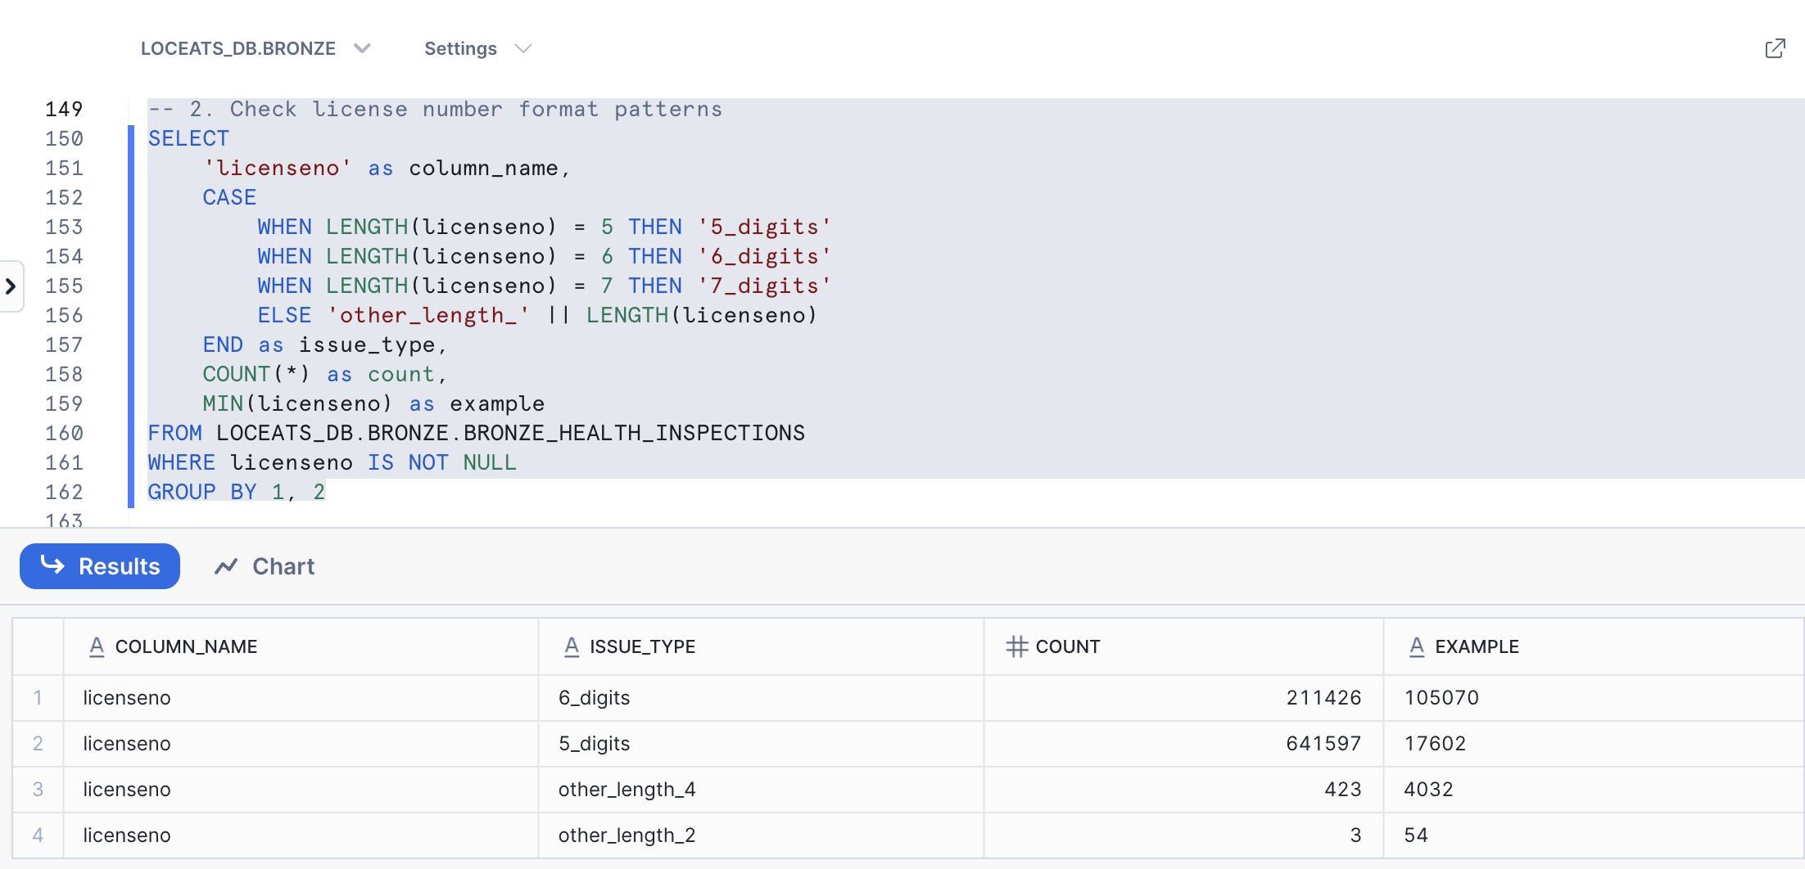
The license number field contains multiple format variations that need standardization. Analysis revealed that 5-digit formats (641,597 records) and 6-digit formats (211,426 records) dominate the dataset, accounting for 99.9% of all entries. Additionally, 423 records contain 4-digit values, and 3 records contain 2-digit values, likely representing data entry errors or truncated entries.
Transformations: All license numbers should be standardized to a consistent 6-digit format by left-padding shorter values with zeros. The 2-digit and 4-digit entries require validation against source systems to determine if they represent legitimate licenses or data quality issues. This standardization will ensure consistent matching and joining operations across the data pipeline.

ZIP Code Standardization Required:
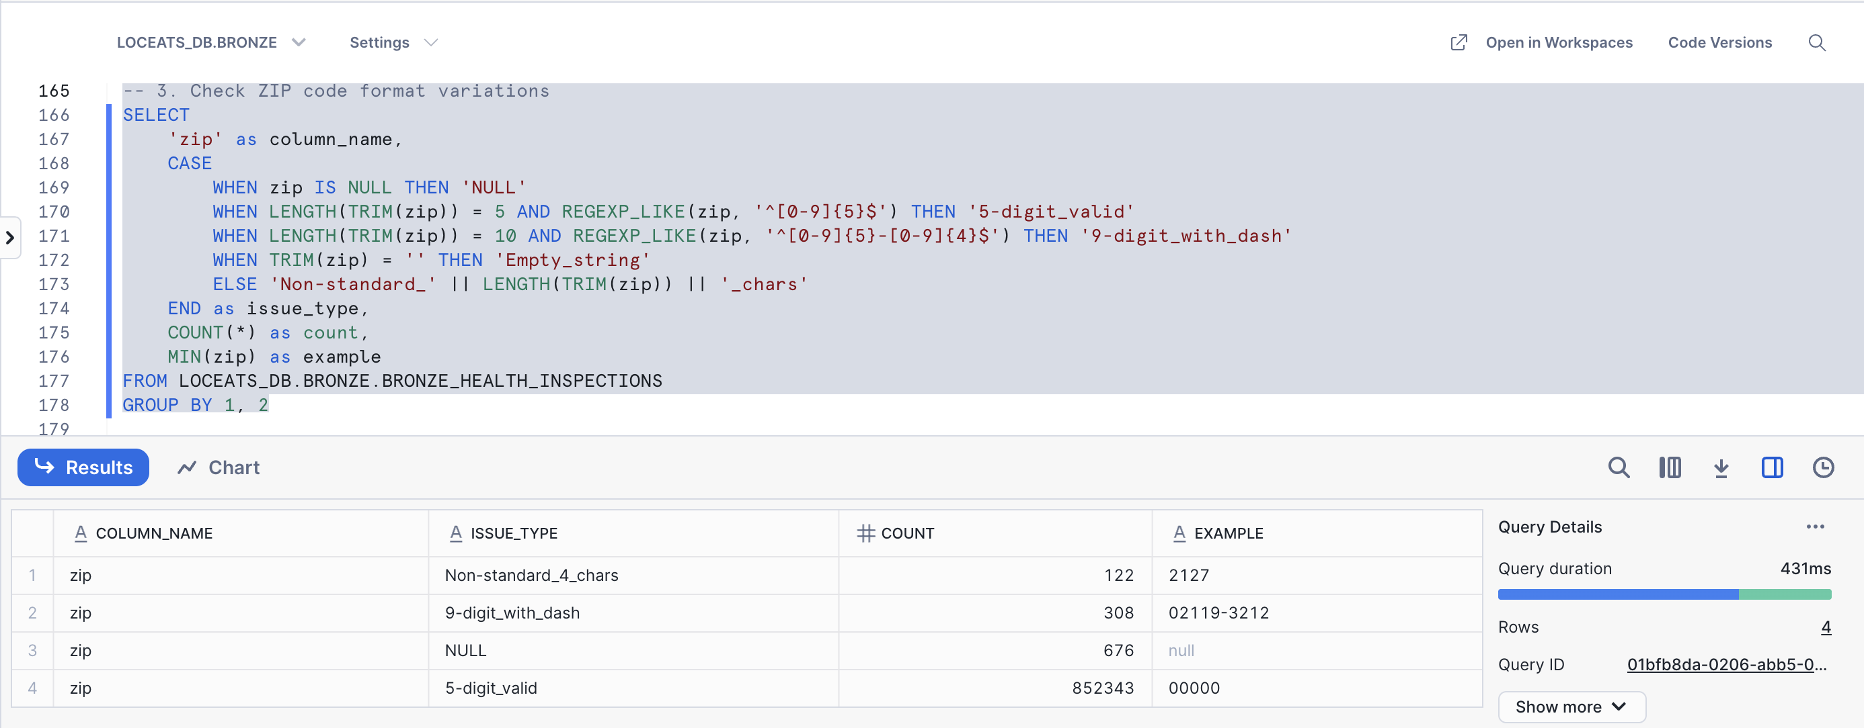
The ZIP code field contains multiple format variations that require standardization. Most records (852,343) contain valid 5-digit ZIP codes, while 308 records contain the extended 9-digit format with dash (e.g., "02119-3212"). Additionally, 122 records contain non-standard 4-character values (e.g., "2127"), and 676 records have NULL values.
Transformation: All ZIP codes should be standardized to the 5-digit format for consistency. The 9-digit ZIP+4 codes should be truncated to retain only the first 5 digits. The 4-character entries require left-padding with zeros to create valid 5-digit codes (e.g., "2127" becomes "02127"). NULL values should be replaced with "00000" or "UNKNOWN" depending on downstream system requirements. This standardization will ensure consistent geographic analysis and matching operations.
State Code Format Inconsistencies:
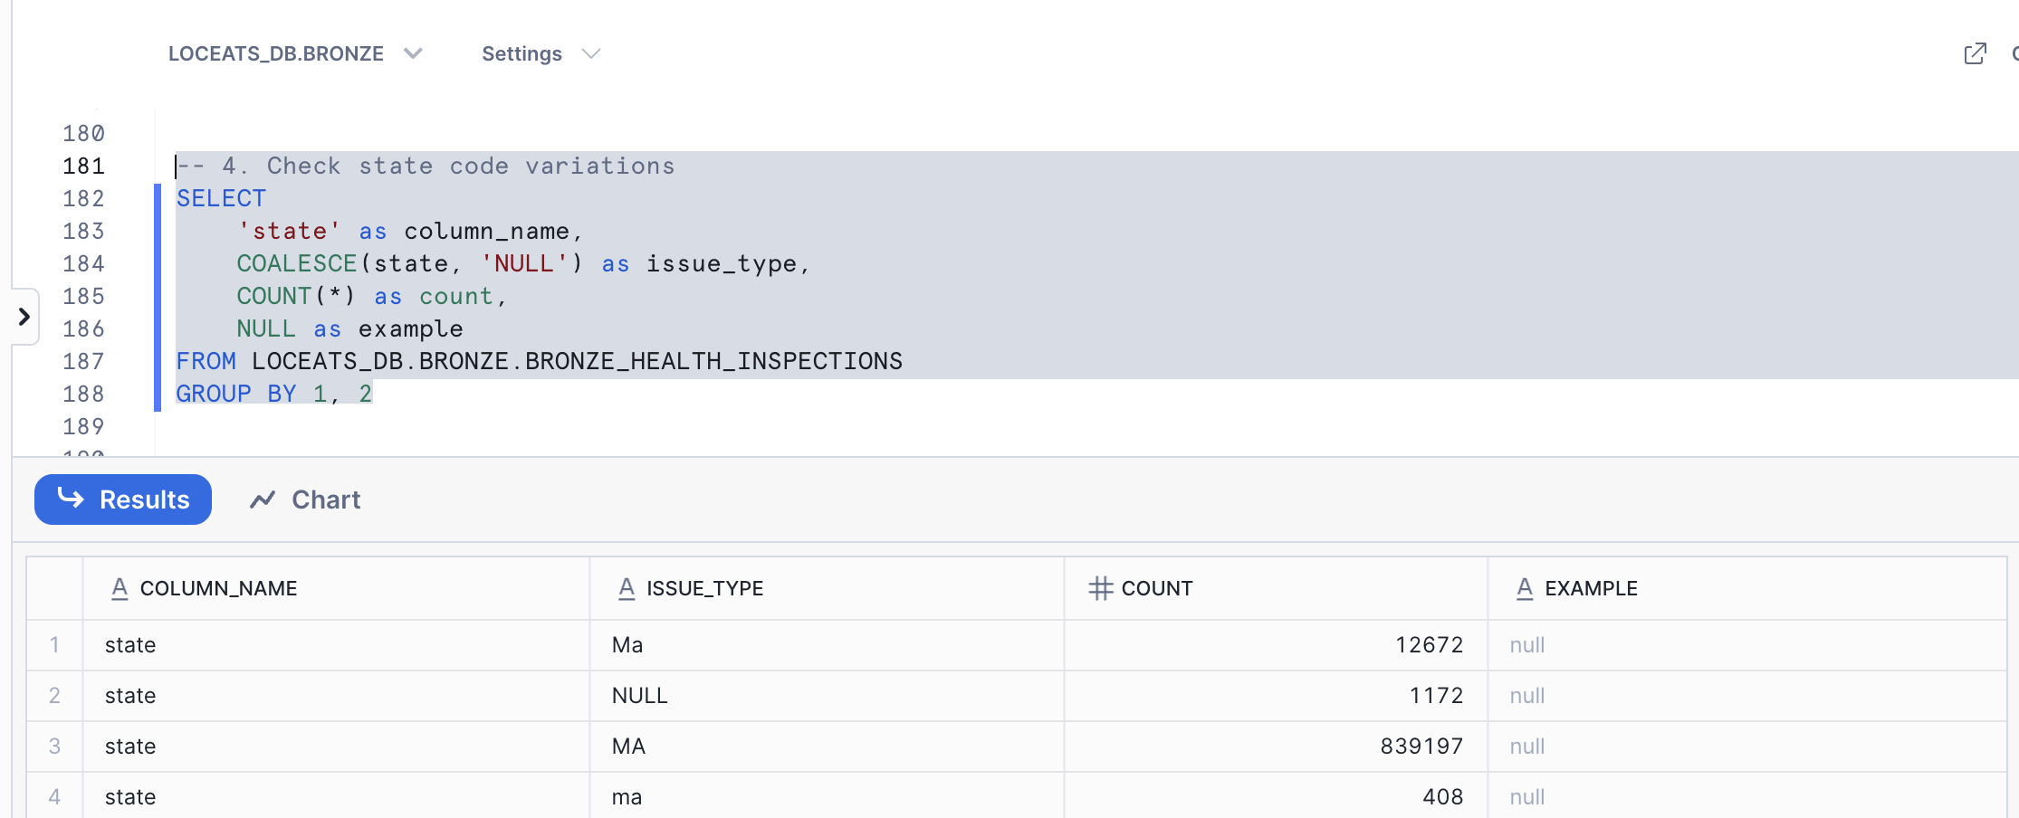

The state field contains multiple format variations that require standardization. Many records (839,197) correctly use "MA" in uppercase, while 12,672 records use mixed case "Ma", 408 records use lowercase "ma", and 1,172 records have NULL values.
Transformations: All state codes should be converted to uppercase two-letter format for consistency. The mixed case "Ma" entries and lowercase "ma" entries will be transformed to "MA" to match the standard format. NULL values should be replaced with "MA" since all data originates from Massachusetts health inspections, making this a safe assumption. This standardization will ensure consistent state code formatting across all 853,449 records and prevent issues in geographic filtering and reporting operations.

Inspection Result Date Inconsistencies:
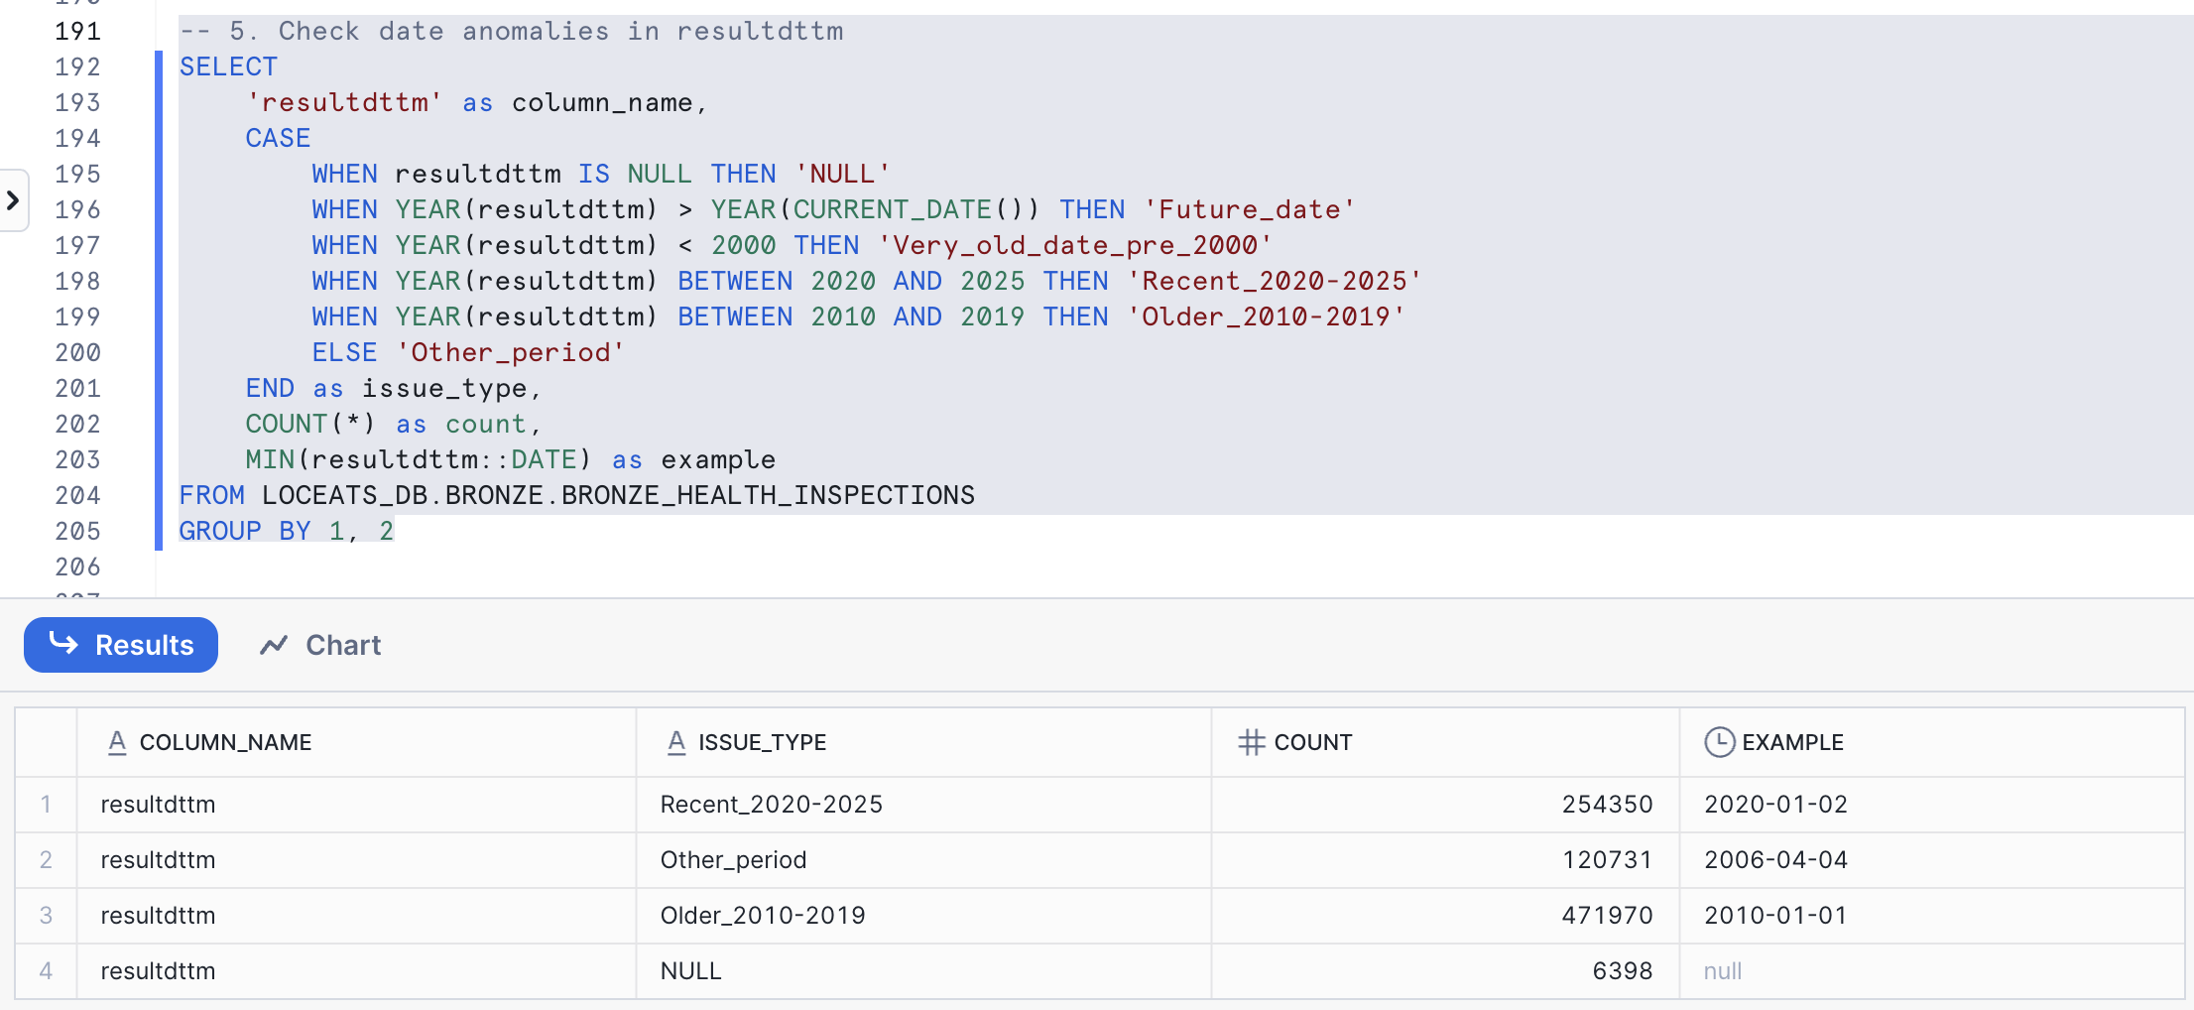
The resultdttm field contains inspection result dates that vary across multiple time periods, with some missing values. Most records (471,970) fall within the 2010–2019 range, followed by 254,350 records between 2020–2025. Additionally, 120,731 records are from other periods outside the expected date range, and 6,398 records contain NULL values.
Transformations: All dates should be validated to ensure they represent accurate inspection timelines. Records classified as “Other period” should be reviewed for data entry errors or incorrect historical data. NULL values should be replaced with valid inspection dates if available or flagged for exclusion from time-based analyses. This will improve temporal consistency and reliability in trend reporting.

Inspection Result Field Variations:
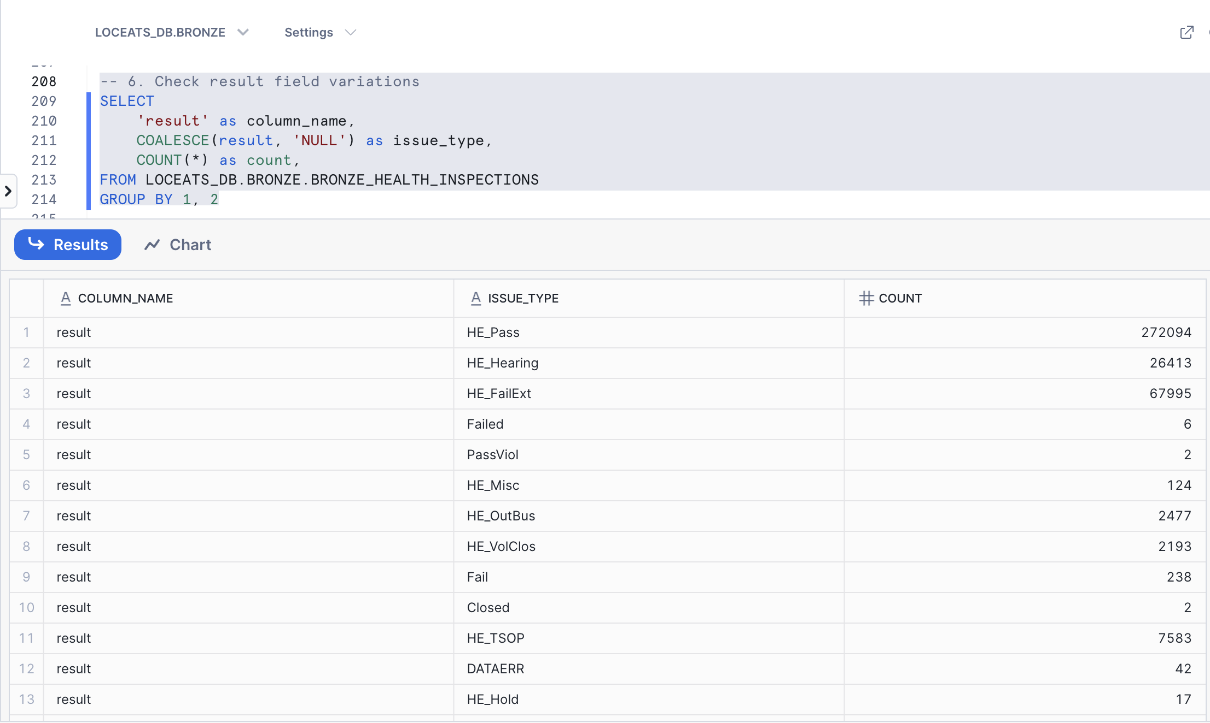

The result field contains multiple format variations indicating inspection outcomes. The most common entries include “HE_Pass” (272,094 records), “HE_Fail” (356,840 records), and “HE_FailExt” (67,995 records). Additional variations such as “HE_Hearing,” “HE_Filed,” “HE_TSOP,” and “HE_Misc” exist alongside less frequent or ambiguous entries like “Fail,” “Failed,” “Pass,” and “Closed.” These inconsistencies suggest mixed coding conventions or legacy data entry practices that require normalization for accurate categorization and reporting.
Transformations: Standardize all inspection result codes into a consistent naming convention. Prefixes such as “HE_” should be uniformly retained or removed across all entries. Synonymous values (e.g., “Fail,” “Failed,” and “HE_Fail”) should be consolidated into a single standard category. Low-frequency or unclear result types should be reviewed for relevance and either reclassified or removed. This will improve the interpretability and reliability of inspection outcome analysis.

City Name Format Consistency:
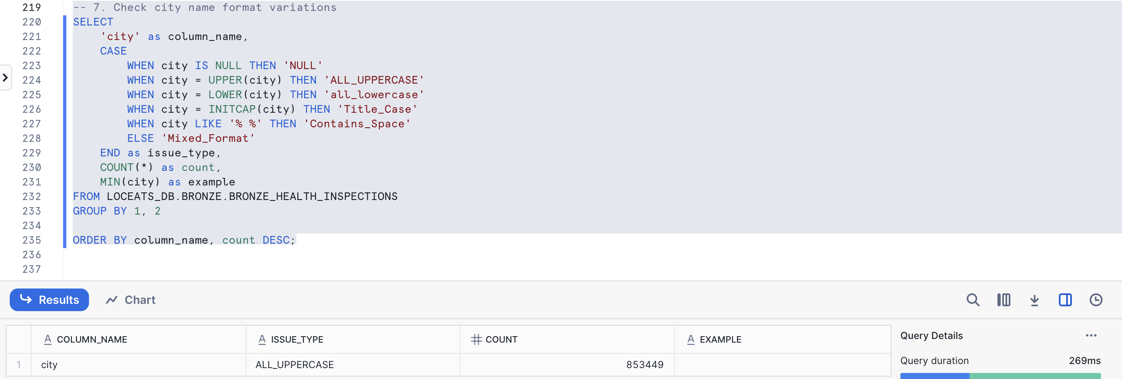
The city field demonstrates uniform formatting across all records, with every entry (853,449) appearing in all-uppercase format. No variations such as lowercase, title case, or mixed formats were detected, and there are no NULL values present in the dataset.
Transformations: Although the data is already consistent, converting city names to title case (e.g., “BOSTON” → “Boston”) may enhance readability for reporting and visualization purposes. Otherwise, no immediate corrective action is required since all records maintain a standardized format.

